**Final Project Interim Report**

**MOD002691**

**Application using procedural generation to assist in the understanding of basic coding.**

**Name: Tom Robinson**

**SID: 1409046**

**Date: 05/11/16**

Contents

1. Project Proposal………………………………………..3
2. Work Plan……………………………………………….4
3. Ethics Certificate……………………………………….5
4. Curriculum Vitae………………………………………..6
5. Exit Plan…………………………………………………8

## **PROJECT PROPOSAL FORM**

|  |  |
| --- | --- |
| ***Name:*** | Tom Robinson |
| ***SID:*** | 1409046 |
| ***Email:*** | tom.robinson2@student.anglia.ac.uk |
| ***Degree course:*** | BCc (Hons) Computer Gaming Technology |
| ***Start of project:*** | September 2016 |
| ***Expected project completion/ submission:*** | April 2017 |
| ***Draft Project Title:*** | Application using procedural generation to assist in the understanding of basic coding. |
| ***Possible supervisor:*** | Mike Hobbs |
| ***Aim(s):*** | - Explore ways procedural generation can be used outside of entertainment.  - Discuss video games as a tool for teaching and research why there is so little variation in teaching methods |
| ***Previous work:*** | - Pervasive learning games, *Siobahn Thomas*, 2006  - Exploring preservice teacher perspectives on video games as learning tools, *Beverly B. Ray, Angiline Powell and Brenda Jacobsen*, 2015 |
| *Methodology and outcomes:* | To achieve this aim I will produce an application that would include basic memory tests which could in turn be used to help students learn the basics of coding. The map on which the player will navigate will be pseudo randomly generated. And will contain enemies to fight the player, every time the player answers a question correctly he will gain a skill to use against roaming enemies and eventually a ‘boss’. The feedback for this application will be able to accurately measure success. |
| ***Resources:*** | Unity (or other editor), Visual Studio, people to test applications. |

Work Plan:

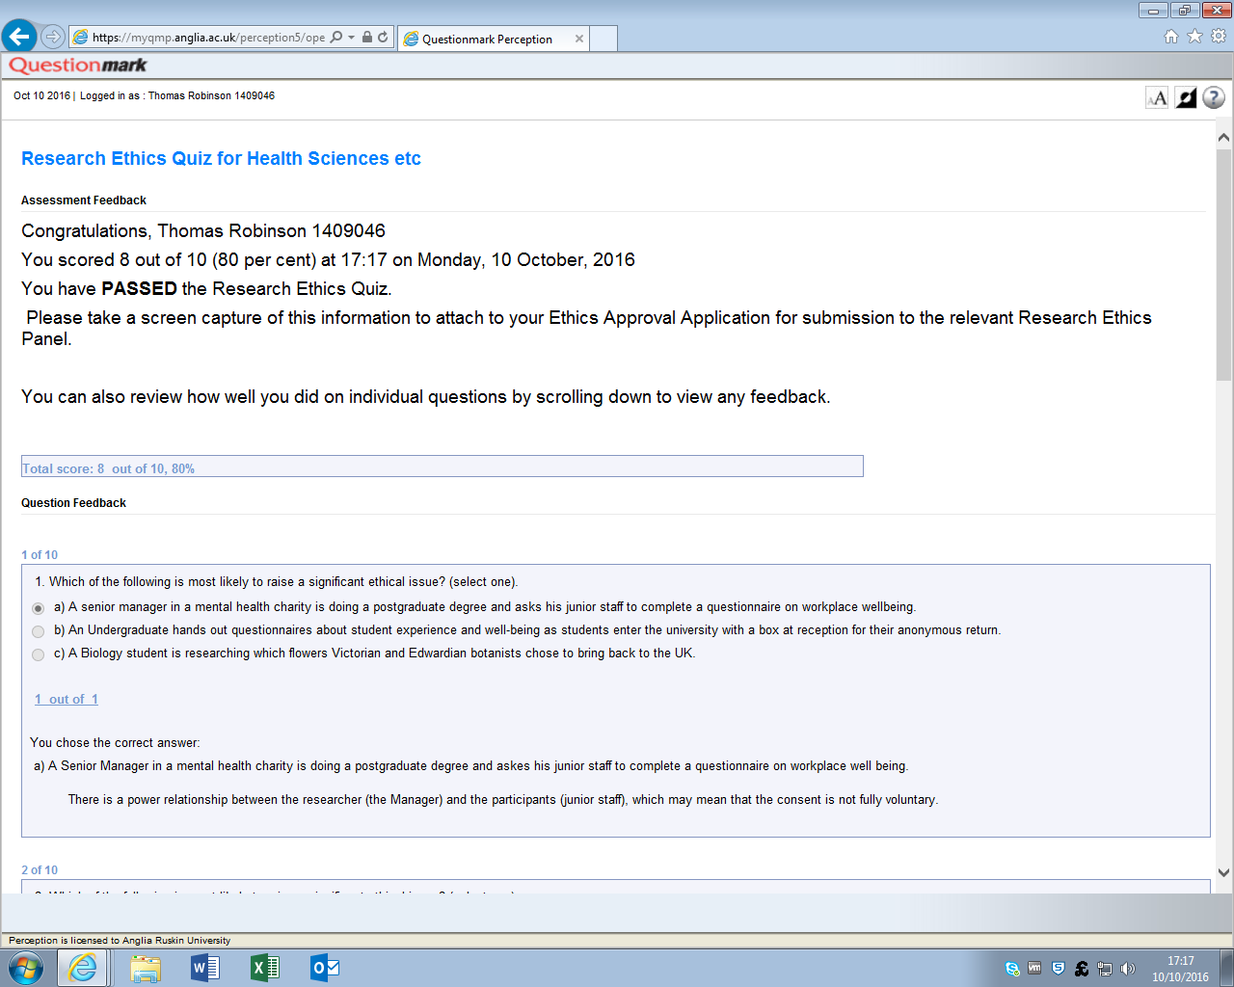Ethics Certificate:

**CURRICULUM VITAE**

Full Name: Thomas James Robinson

Address: 49 Goldstone Crescent, Hove, England

E-mail: tom.robinson1996@hotmail.com

Telephone No: (01273) 507958 Mobile: 07793471619

|  |
| --- |
|  |

**KEY SKILLS**:

Personal Skills:

Organisation is a value which I am keen to install into a work or home environment.

I enjoy solving problems and helping others achieve their goals.

I am committed to working hard and I am passionate

about exceeding expectations.

I have a qualification in French and basic Mandarin

Punctuality is a key value that I always stick to.

I am very good at working in a team but I am also

very productive working individually.

I adapt to new environments or roles quickly and smoothly

Quick to establish strong relationships, professional and personal.

Confident in the face of new challenges and problems

Technical Skills:

Programming Languages learnt:

* Advanced C#
* Basic C++
* Basic HTML
* Basic SQL
* Basic Java

Software used:

* Unity 3D
* 3DS Max
* Unreal Engine
* Visual Studio
* Adobe Dreamweaver
* All Microsoft Office applications

I can touch-type and skim read.

I also have good maths skills which allow me to do quick numeracy.

**Education:**

|  |  |  |  |
| --- | --- | --- | --- |
| COURSE TITLE: | LEVEL: | Institution: | Result: |
| Computer Games Technology | BSc | Anglia Ruskin University | 2:1 (prediction) |
| Maths | A Level | BHASVIC | D |
| Biology | A Level | BHASVIC | C |
| ICT | A Level | BHASVIC | C |

As well as the qualifications mentioned above I also have 12 strong GCSE’s ranging from A* to B including English, Maths and Science

**CERTIFICATES & MEMBERSHIPS**:

|  |  |
| --- | --- |
| Certificate or Membership | Date achieved |
| Duke Of Edinburgh Bronze Award | June 2012 |
| Hurstpierpoint FC Youth | 2007- 2014 |
| Sports Leader Level 1 | June 2012 |
| Brighton Marathon | April 2016 |

**EMPLOYMENT & WORK EXPERIENCE:**

Job Title: Ball Boy

Company name / location: American Express -

Community Stadium

Website: www.seagulls.co.uk

Dates of Employment: July 2011 – May 2013

Job Title: Paper boy Job Title: Sales Advisor

Company name / location: Leader Company Name / Location: Dorothy Perkins

(Arcadia Group)

Website: <http://www.leaderbrighton-hove.org/> Website: http://www.dorothyperkins.com/

Dates of Employment: July 2011 – June 2013 Dates of Employment: June 2013 – September 2014

Job Title: Warehouse Assistant

Company name / Location: Sainsburys,   
 Cambridge and Brighton

Website: [www.sainsburys.co.uk](http://www.sainsburys.co.uk)

Dates of Employment: October 2014 - Present

Job Title: Change Management

Company name / Location: City University London

Website: www.city.ac.uk/

Dates of Employment: October 3rd- October 7th 2011

**PERSONAL INTERESTS:**

I enjoy using new and interesting technology on a regular basis, I also enjoy studying hard and overcoming new challenges, both academically and within day to day activities. Making games and completing online tutorials for coding is something I like to do as I know that the industry moves so quickly and it is important to keep up with the latest practices. I also enjoy running and completed the Brighton marathon in 2016.

**REFERENCES:**

Available upon request

Exit Plan

After graduating I plan to apply for a master’s degree in general computer science, I have enjoyed learning to create games but I think that to widen my potential employers having a wider knowledge base in computing will be useful. I would like to go to America somewhere to undertake this course but this will require more research. I am currently working for Sainsbury’s so will continue to do so post-graduation, this will help me raise funds to study in America. I will more than likely move back to my hometown as there is good links to London and other areas so I wouldn’t have any problem finding locations for jobs in the gaming or computer science industries if I decided to go straight into employment.

After finishing my master’s, I would like to travel because I will have been in education for all my adult life but I am also open to the prospect of a graduate scheme as I would have to think about how much money I would have after my master’s. I am open-minded about future careers, having a job creating games would be very interesting but I am not 100% set that this is where I want to have a career. I will evaluate my options again when I have finished my final degree course.